Title of the paper (max 2 lines allowed) 24/24 (paragraph), 14pt,

(IF THE TITLE IS IN CROATIAN, IT MUST ALSO BE IN ENGLISH)

First Author¹, Second Author², Third Author³, Fourth Author⁴ (max 4), Latin alphabet, 0/6, 11pt
¹ Title, Organization, Country, e-mail, 0/0, 10 pt
² Title, Organization, Country, e-mail, 0.0, 10 pt
³ Title, Organization, Country, e-mail, 0,0 10 pt
Abstract (18/0, 10pt). The abstract should give a brief overview of the most relevant aspects of the paper. It is required that the abstract is structured as follows: purpose of the research, methodology, main results and major conclusions. Authors are requested to avoid using references and uncommon abbreviations in the abstract. It is essential that the abstract is able to stand alone (separately from the whole manuscript). The extent of the abstract: up to 1200 characters. It is important that title, authors, contact-addresses, abstract and keywords.
Key words (12/0, 10pt). Authors have to provide a minimum of 4 and maximum of 6 keywords that best describe original content of the paper, alphabetically sorted and separated by comma.

introduction (New page, capital letters), 12/6, 11pt, numbering 0., hanging 0,63
The paper should be prepared for printing on paper format A4 (210x297 mm). We recommend you use this template and insert the text here, with already defined styles and other required customizations. The entire text of the article should be in Arial font. The extent of the paper: 6 - 12 pages including appendix.
  - Subtitle (Sentence letters), 12/6, 11pt, hanging 0,9

Structure of the paper
Paper depends on its content, but authors are strongly recommended to divide the manuscript into clearly defined and numbered sections. The structure should be prepared as follows:
- Introduction (state the aim of the research)
- Literature Review/Background (please use mostly up-to-date literature published in internationally recognized journals; only published articles/works can be used as references)
- Methods/Methodology (provide enough detailed information on research done to enable your research to be reproduced)
- Results (results must be clear and transparent)
- Discussion (explain the substance and importance of achieved results)
- Conclusion (give most important conclusion from your paper)
- References (requirements for referring other papers are given below)

Figures
All figures (charts, drawings and photos) should be provided in usual format (gif, jpg, bmp), should be of sufficient quality. They are numbered according their appearance in the paper (1, 2, 3, …). References to all figures have to be made inside the text, in order to ensure connections between the text and the information from the figure.
0/0, 6pt
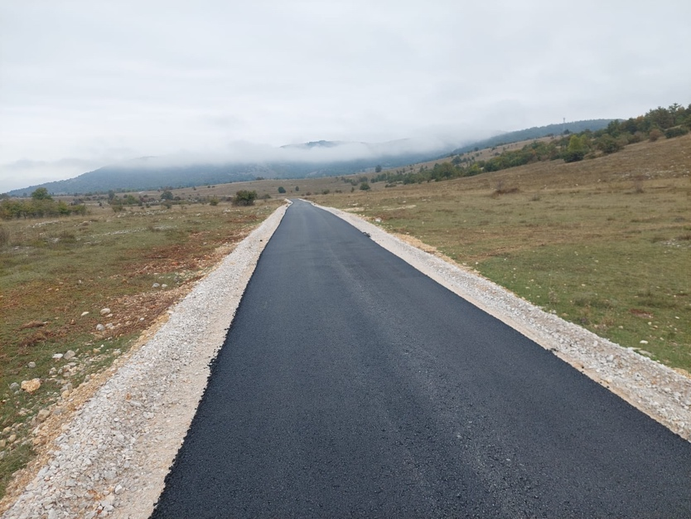
0/0, 6pt
Fig. 1: Caption for the figure, 0/0, 10pt
Source:

Tables
Tables are constituent part of the document. They are numbered according their appearance in the paper (1, 2, 3, …). All tables should be Black & White or Greyscale. References to tables have to be made inside the text, in order to ensure connections between the text and the information from the table.

Table 1. Caption for the table
Type of bituminous mixture | Thickness d (cm) | Area (m²)
SMA 11s PmB 45/80-65 surf | 4,0 | 1155,27
AC 22sA PmB 45/80-65 base | 10,0 | 1155,27
Source:

Other Requirements
Papers that are not prepared according to formatting instructions will not be reviewed and will be returned to authors for corrections.
We expect authors, reviewers and editors commit to publication ethics in order to ensure high quality of published contributions in PBE conference proceedings. PBE's Publication Ethics and Publication Malpractice Statement is based, in large part, on the guidelines and standards developed by the Committee on Publication Ethics (COPE).

Equations, numbering 0.0., left 0, 6/6, hanging 1
Equations should be centred and numbered according to their appearance in the text.
Z = S + T (1)

Abbreviations
Use of abbreviations has to be reduced to minimum. Generally used units can be used without their definitions.

Footnotes
It is NOT allowed to use footnotes to the text.

Language
All abstracts and full papers must be written in Croatian and English language.
    - Numbering with three digits 0.0.0., left 0, 6/6, hanging 1.27

rESULTS
Results must be clear and transparent.

DISCUSSION
Explain the substance and importance of achieved results.

ConCLUSIONS
Give the most important conclusions from your paper.

References
References should be brought together at the end of the manuscript and numbered in order of their appearance in the text. When reference to literature is made the publication number from the list of references in square brackets is used like "[4] the authors introduce ...". The references have to appear in the text of the manuscript. Please provide URLs and DOI for the references where available. Authors are responsible for obtaining permission to reproduce copyright material from other sources.
NOTE:
- The Acknowledgments of people, institution, organization, grants, funds, etc should be brief.
- The document should be sent in .docx and .pdf format

